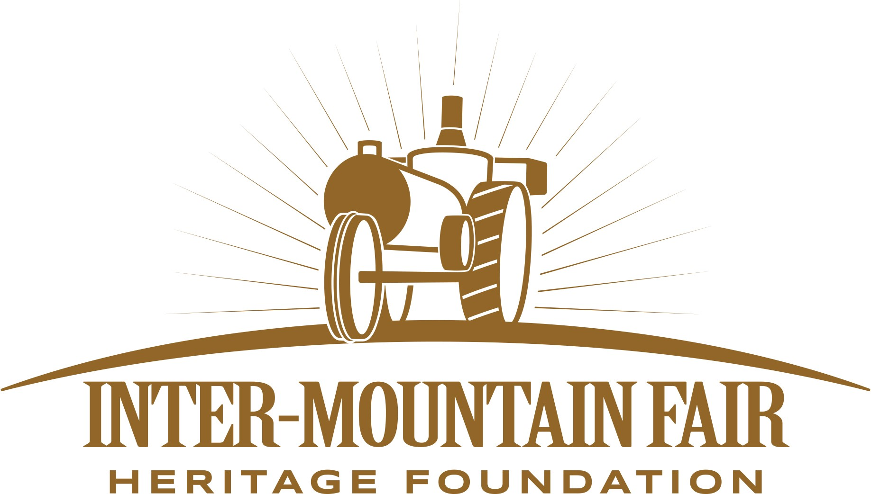

Inter-Mountain Fair Heritage Foundation
Board of Directors

Regular Meeting Agenda
Monday, September 28, 2026
6:00 PM – Heritage Room, Ingram Hall
44218 A Street, McArthur, CA
www.inter-mountainfair.com

1 | Call Meeting to Order
2 | Pledge of Allegiance
3 | Call for Request from the Audience – Public Comments or to Speak to Agenda Items
Persons wishing to address the Board are requested to fill out a “Request Form” prior to the beginning of the meeting (forms are available upon entrance into the meeting room). If you have documents to present for the members of the Board of Directors to review, please provide a minimum of 20 copies. When the President announces the public comment period, requestors will be called upon one-at-a-time, please stand and give your name and comments. Each speaker is allocated five minutes to speak. Comments should be limited to matters within the jurisdiction of the Board. Pursuant to the Brown Act (Govt. Code section 5450 et seq.) action or Board discussion cannot be taken on open time matters other than to receive the comments and, if deemed necessary, to refer the subject matter to the appropriate department for follow-up and/or to schedule the matter on a subsequent Board Agenda.
4 | Approval of Minutes
 | 4.1 |  | Regular Meeting –August 17, 2026 |  |  | Attachment A | Action Item
5 | General Manager’s Report:
 | 5.1 |  | GM Report |  |  |  | Report
 | 5.2 |  | Jr. High State Finals
 | 5.3 |  | Jr. Rodeo Donation
 | 5.4 |  | Chainsaw Carving Festival
6 | Board Committees
 | 6.1 |  | Financial Committee and Treasurers’ Report
 |  |  | 6.1.1 | Committee Report |  |  | Report
 |  |  | 6.1.2 | Foundation Financials |  | Attachment B | Action Item
 |  |  | 6.1.3 | Bills to Report |  |  | Action Item
 |  |  | 6.1.4 | Fair and Event Center Financials |  | Attachment C | Action Item
 | 6.2 |  | Executive Committee
 |  |  | 6.2.1 | Committee Report |  |  | Report
 | 6.3 |  | Inter-Mountain Fair Committee
 |  |  | 6.3.1 | Committee Report |  |  | Report
 |  |  | 6.3.2 | Fair Recap |  |  | Discussion
 |  |  | 6.3.3 | Community Input |  |  | Discussion
 | 6.4 |  | Jr. Livestock Committee
 |  |  | 6.4.1 | Committee Report |  |  | Report
 | 6.5 |  | Facilities Committee
 |  |  | 6.5.1 | Committee Report |  |  | Report
 | 6.6 |  | Sponsorship Committee
 |  |  | 6.6.1 | Committee Report |  |  | Report
 | 6.7 |  | Grant/Fundraising Committee
 |  |  | 6.7.1 | Committee Report |  |  | Report
7 | Old Business
 | 7.1 |  | State Allocation |  |  |  | Discussion
 | 7.2 |  | Tulip Festival and Purchase
 | 7.3 |  | Sound System
 | 7.5 |  | Brown Act Training
 | 7.6 |  | Equipment for Equine Facility
8 | New Business
 | 8.1 | Friends Giving |  |  |  |  | Discussion
 |  | November 14th, 2026 Ingram Hall, Doors open at 4pm
 | 8.2 | Donation for Veterans Memorial Plaques |  |  |  |  | Discussion
 | 8.3 | Motion to purchase metal for plagues for $3,000 and to be managed by the Inter-Mountain Fair. |  |  |  |  | Action Item
 | 8.4 | Motion to donate to Redding Non-Profit |  |  |  |  | Action Item
 | 8.5 | Nomination Committee |  |  |  |  | Discussion
 | 8.6 | Elections and Officers |  |  |  |  | Discussion
9 | Other Information or Announcements
10 | ADJOURNMENT |  |  |  |  |  | Action Item
 | Next Meeting: September 21 or 28th, 2026

